AE63.PROD.BENP.EXE(**PPR00**)

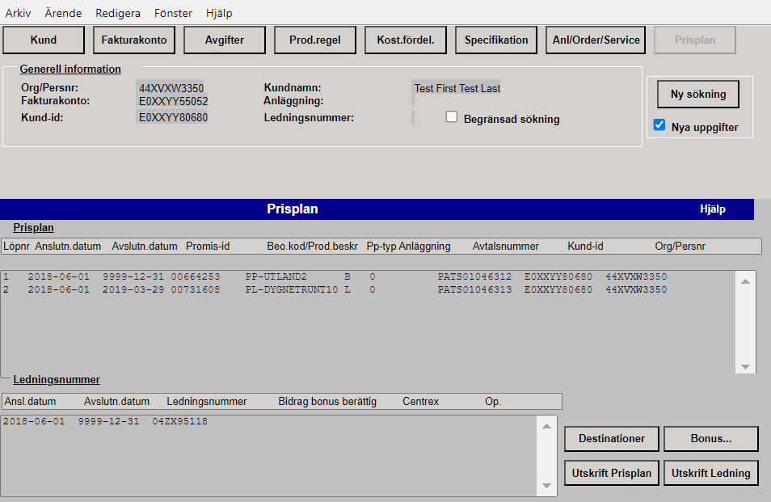

It executes SPUFI: pps01 to get require details with customer number as predicate.

pps04 to get other details with customer number as predicate.

OR

pps02 with customer and chargeable number as predicate.

pps05 with customer and chargeable number as predicate.

In the program we do have validation, for chargeable number = space customer number flow is executed, or some value chargeable number flow is executed.

Below details are fetched by pps01 or pps02.

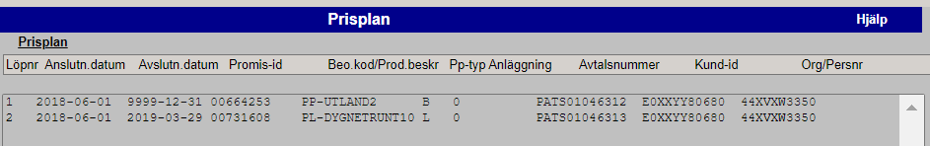

Below details are fetched by pps04 or pps05.

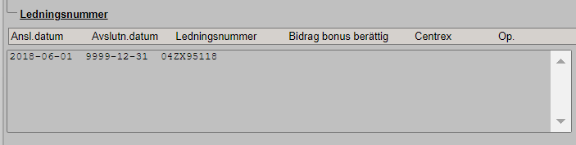

AE63.PROD.BENP.EXE(**DER00**)

It executes SPUFI: des01 to get destination details.

des02 to get area details.

des03 to get category details.

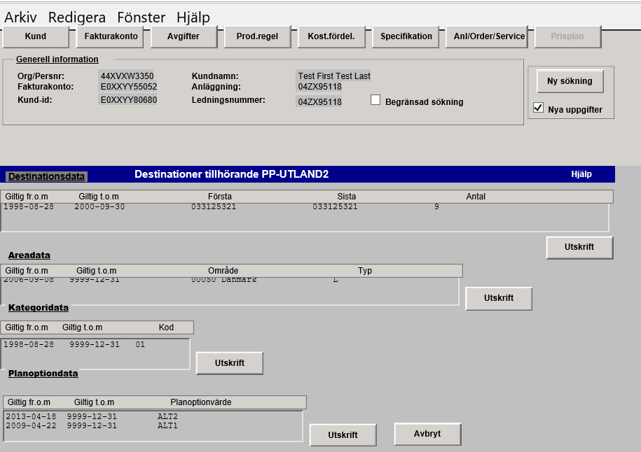

Below details are fetched by SPUFI des01.

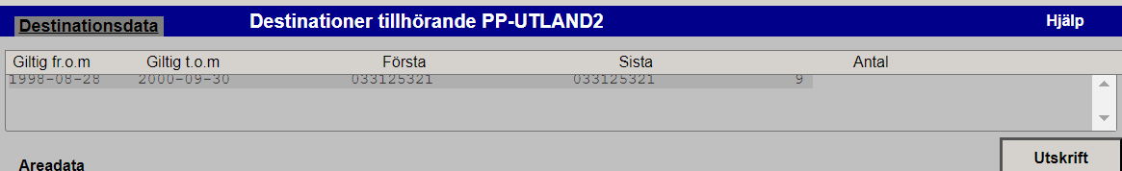

When ‘Utskrift’ near Destinationsdata (Above Screen) is clicked below details are fetched by program AE63.PROD.BENP.EXE(**DEL00**) SPUFI dest00.

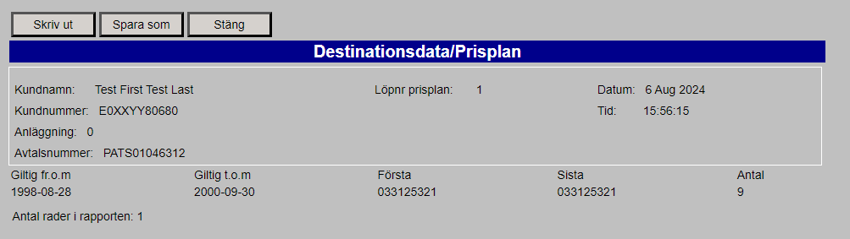

The number of records shown under the table will be displayed against ‘Antal rader I repporten: XXX’. In above case it is one.

Below details are fetched by SPUFI des02.

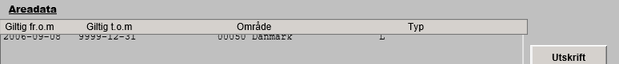

When ‘Utskrift’ near Areadata (Above Screen) is clicked below details are fetched by program AE63.PROD.BENP.EXE(**DEL01**) SPUFI area00.

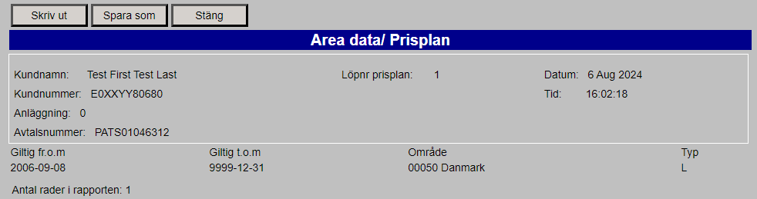

The number of records shown under the table will be displayed against ‘Antal rader I repporten: XXX’. In above case it is one.

Below details are fetched by SPUFI des03.

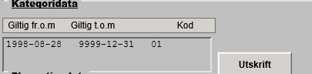

When ‘Utskrift’ near Kategoridata (Above Screen) is clicked below details are fetched by program AE63.PROD.BENP.EXE(**DEL02**) SPUFI kat00.

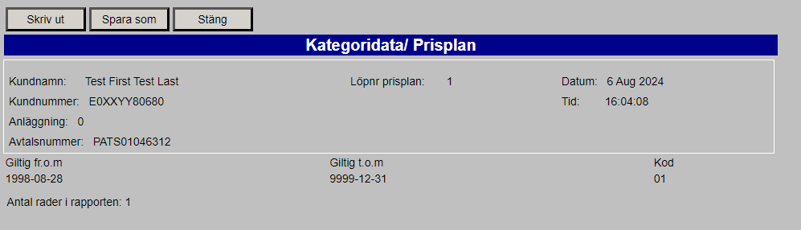

The number of records shown under the table will be displayed against ‘Antal rader I repporten: XXX’. In above case it is one.

Below details are fetched by SPUFI des04.

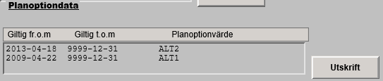

When ‘Utskrift’ near Planoptiondata (Above Screen) is clicked below details are fetched by program AE63.PROD.BENP.EXE(**DEL03**) SPUFI plano00.

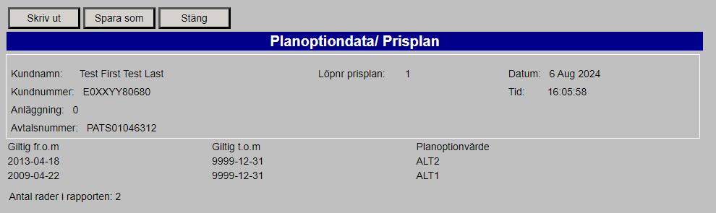

AE63.PROD.BENP.EXE(**PPL00**)

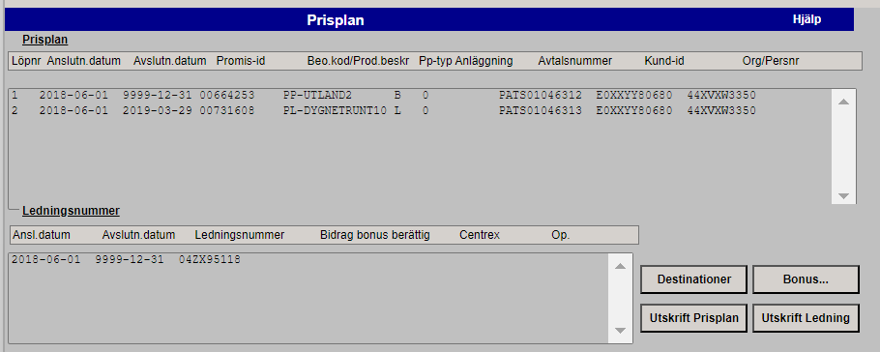

The above program is used to fetch below details when ‘Utskrift Prisplan’ tab is clicked on above screen. This is done using SPUFI pps01 or pps02. The SPFUI pps01 is used when we search using customer number only. The other SPUFI pps02 is used when customer number and chargeable number is used. Below screen shot is for customer search:

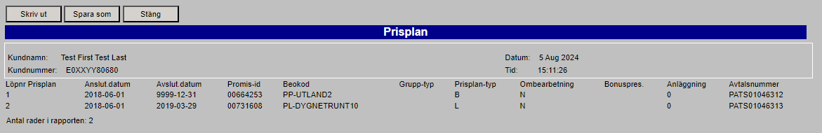

The number of records shown under the table will be displayed against ‘Antal rader I repporten: XXX’. In above case it is two.

Below one is for customer and chargeable number together.

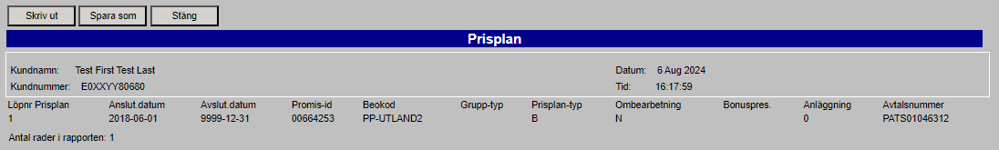

The number of records shown under the table will be displayed against ‘Antal rader I repporten: XXX’. In above case it is one.

For other customer ID: E0XXXY58966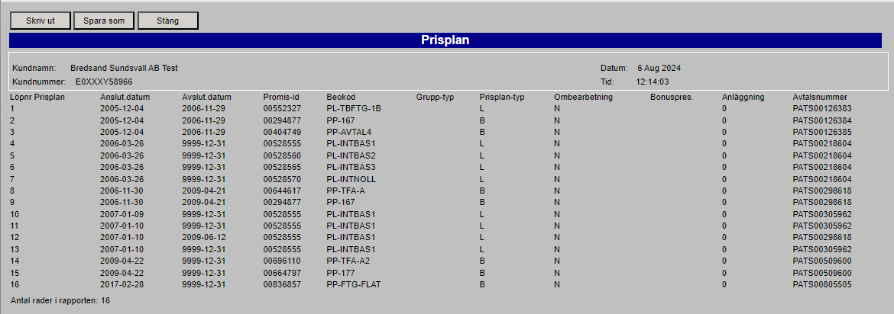

The number of records shown under the table will be displayed against ‘Antal rader I repporten: XXX’. In above case it is sixteen – 16.

AE63.PROD.BENP.EXE(**PPL01**)



The above program is used to fetch below details when ‘Utskrift Ledning’ tab is clicked on above screen. This is done using SPUFI pps01 or pps02. The SPFUI pps01 is used when we search using customer number only. The other SPUFI pps02 is used when customer number and chargeable number is used. Below screen shot is for customer search:

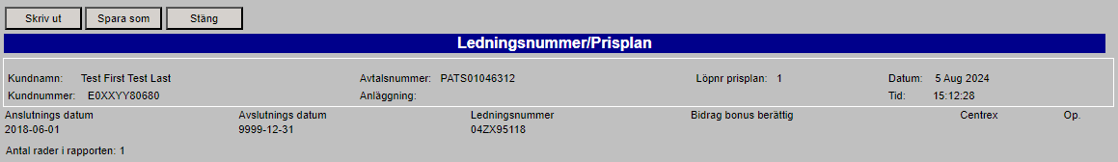

In case of no data in database we get below warning message.

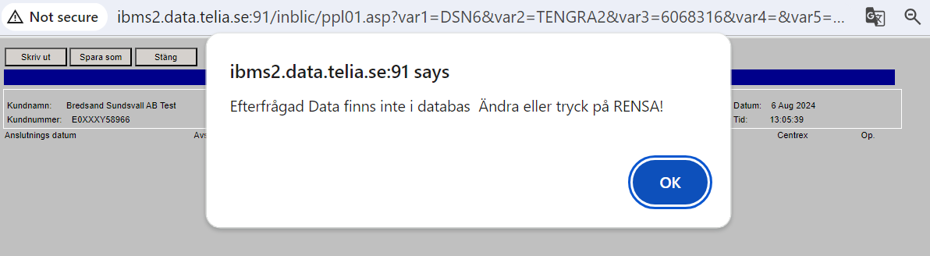

**Below existing functionality can be removed:**

AE63.PROD.BENP.EXE(**BOR00**) – No data in Production/AT/ST region for this, so we can ignore it after confirming with other Telia users. On 8th August DSTUM Prashant B. confirmed that the bonus functionality is decommissioned long back, hence we can remove it in new design.

